**Experiment 06: Split Range Control**

**Name: Shaunak Deshpande**

**Div.: TY-IC-C**

**Roll. No.: 39**

**GR no.: 11911180**

**Batch.: 2**

**Class : TY B.Tech Instrumentation & Control**

**Course Name : Building & Process Automation**

The process example used in this workshop is the green liquor temperature process. The process inlet temperature is a disturbance input. Green liquor temperature is maintained at setpoint by manipulating the water to a cooler or the steam to a heater. The process is shown below.

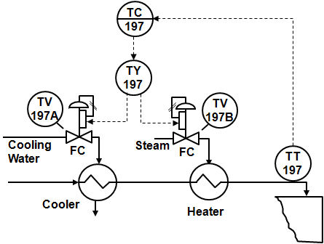

**Steps:**

Step 1. In the split-range control workspace, change the mode of the splitter block to Auto.

Step 2. Change the splitter SP (setpoint) over the following range: 0, 25, 50, 75, and 100. Observe the changes in the valve positions and process outlet temperature.

Step 3. Change the splitter SP (setpoint) to 50 and wait until the temperature settles to a fixed value.

Step 4. Make a step change in the FEED_TEMP disturbance and manually adjust the splitter setpoint to get the OUT_TEMP back to its initial value.

Step 5. Change the splitter mode to Cascade, change the temperature control setpoint and observe the response.

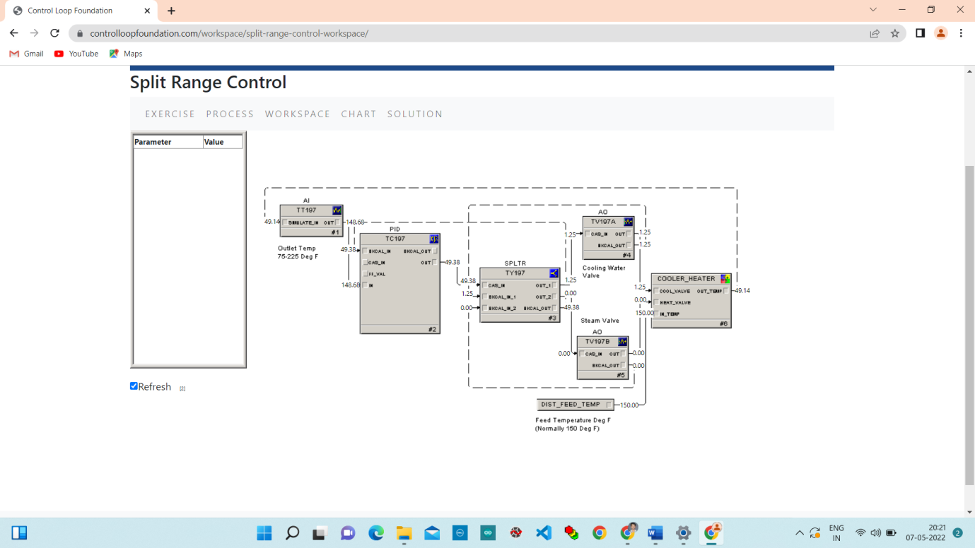

**Step 1.** In the split-range control workspace, change the mode of the splitter block to Auto.

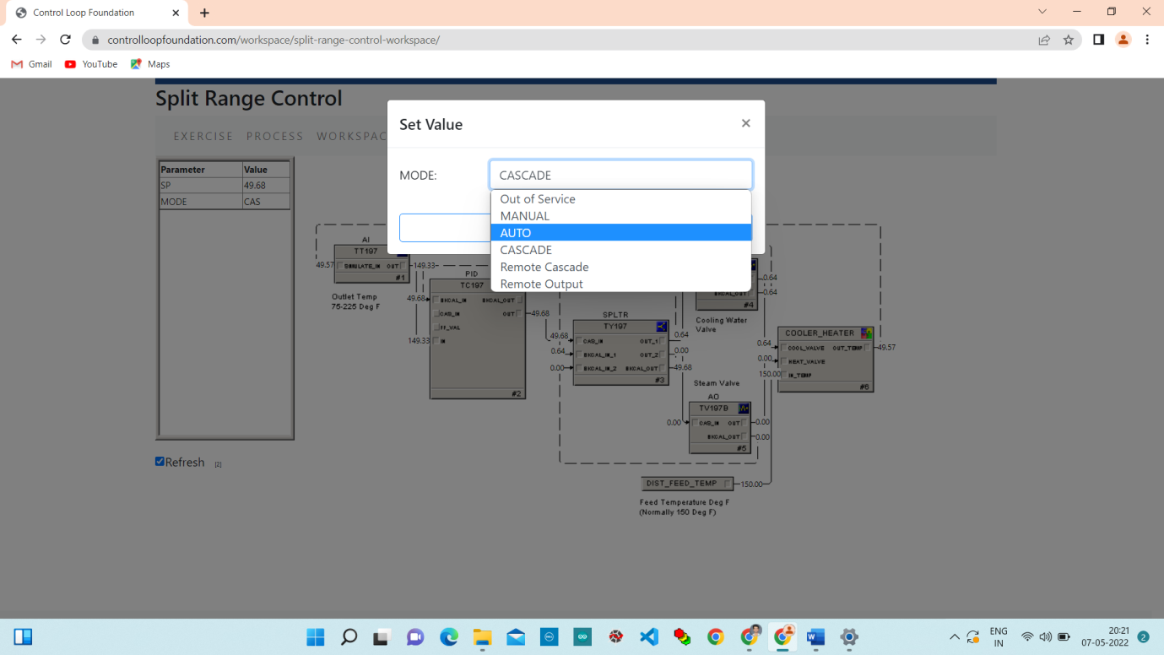

**Step 2.** Change the splitter SP (setpoint) over the following range: 0, 25, 50, 75, and 100. Observe the changes in the valve positions and process outlet temperature.

Change setpoint 50 to 0.

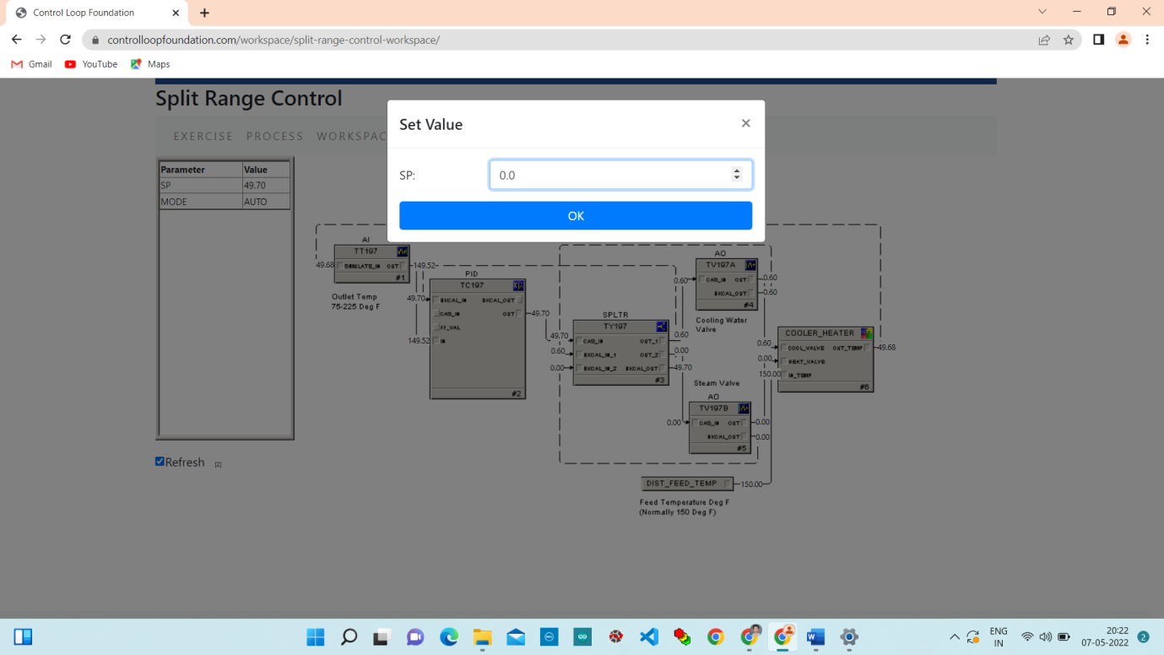

Change setpoint 0 to 25.

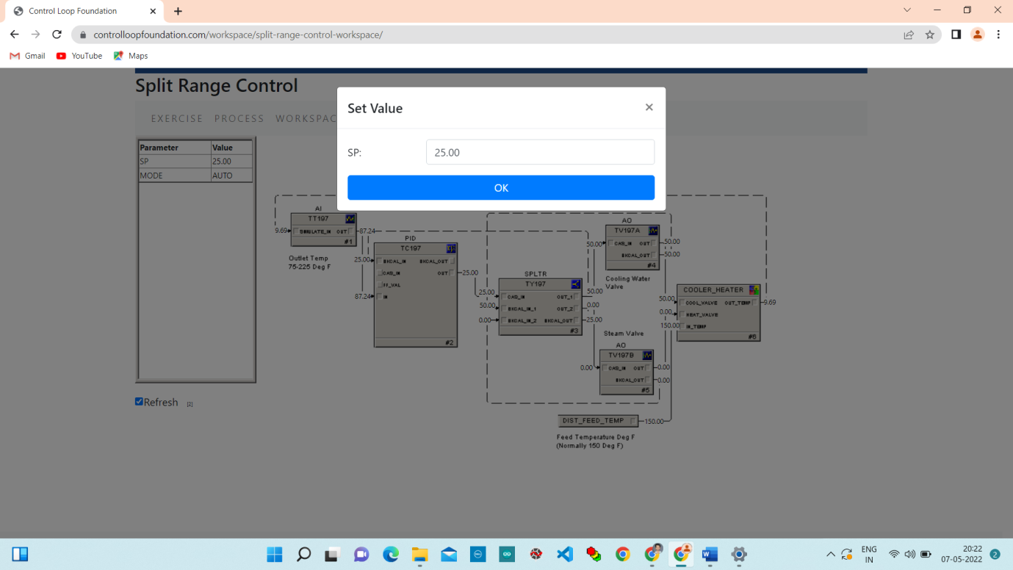

Change setpoint 25 to 50.

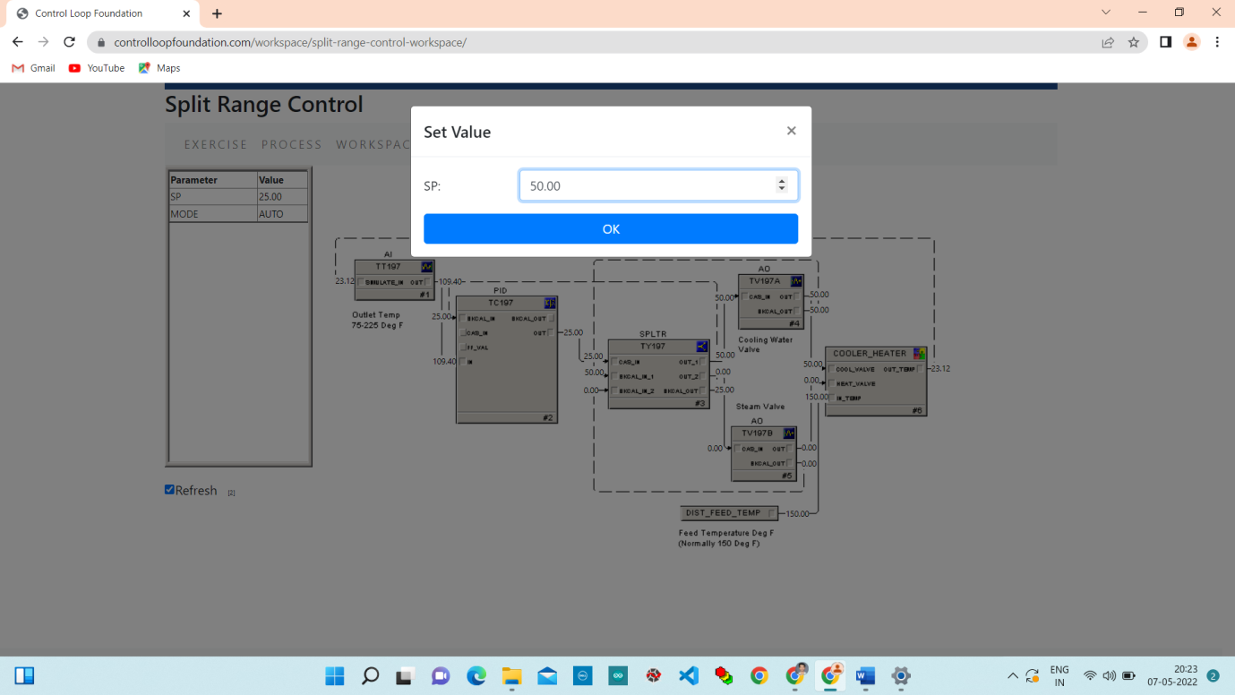

Change setpoint 50 to 75.

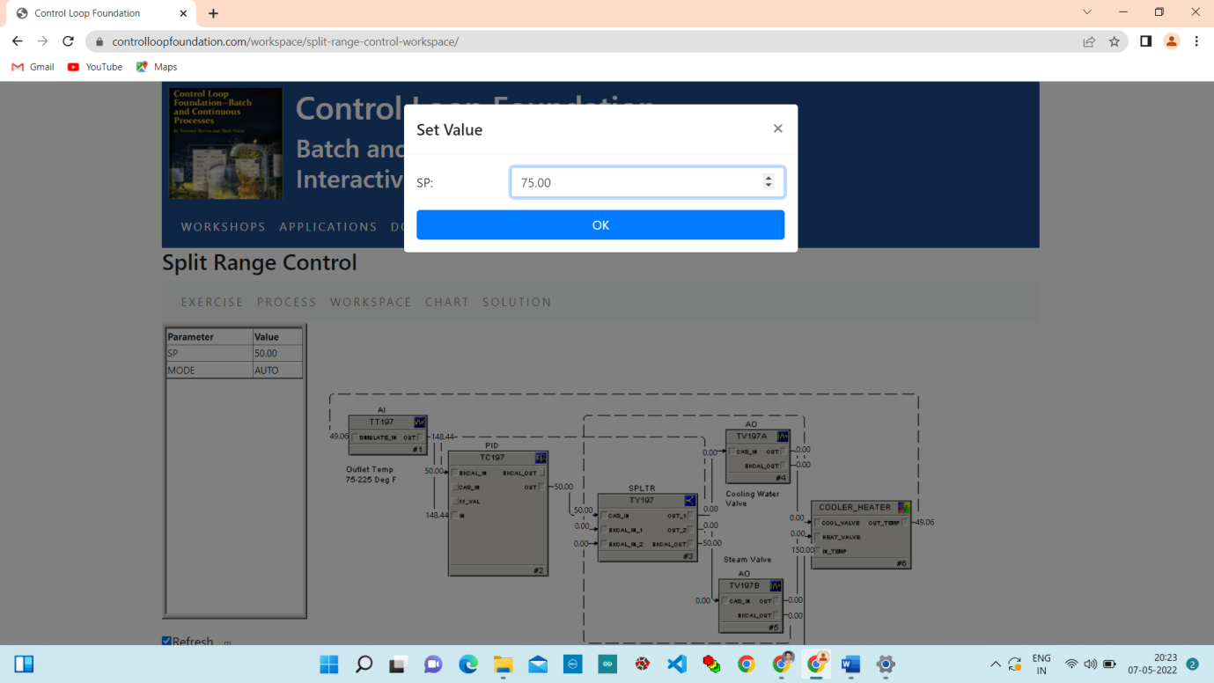

Change setpoint 75 to 100.

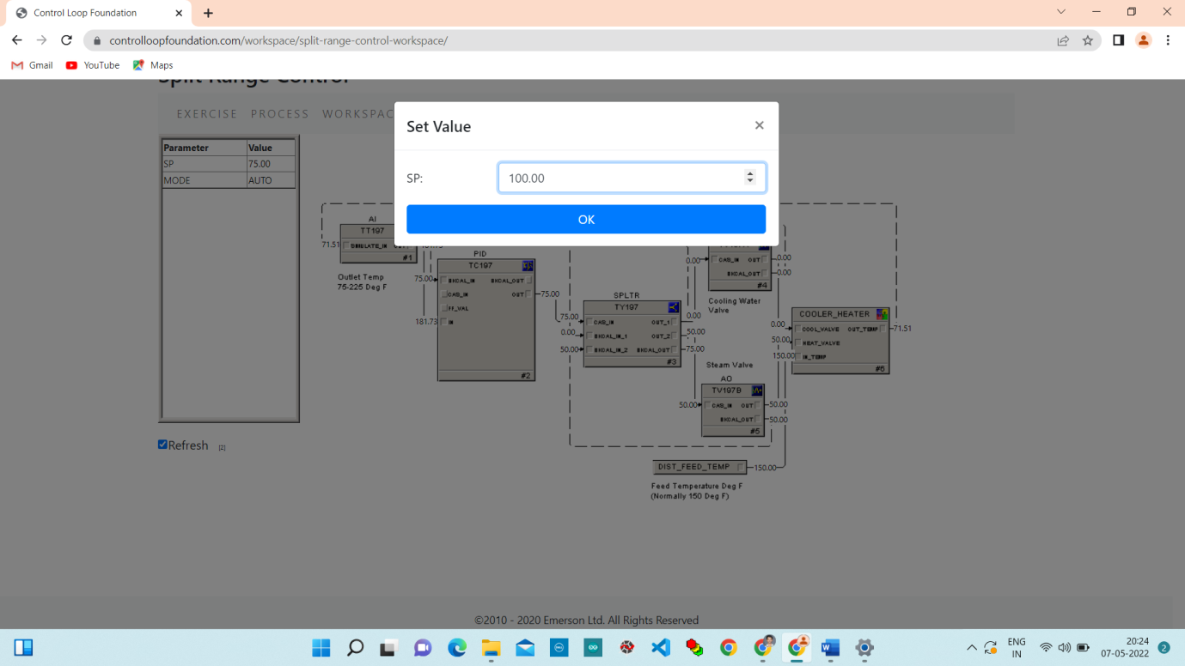

**Chart:**

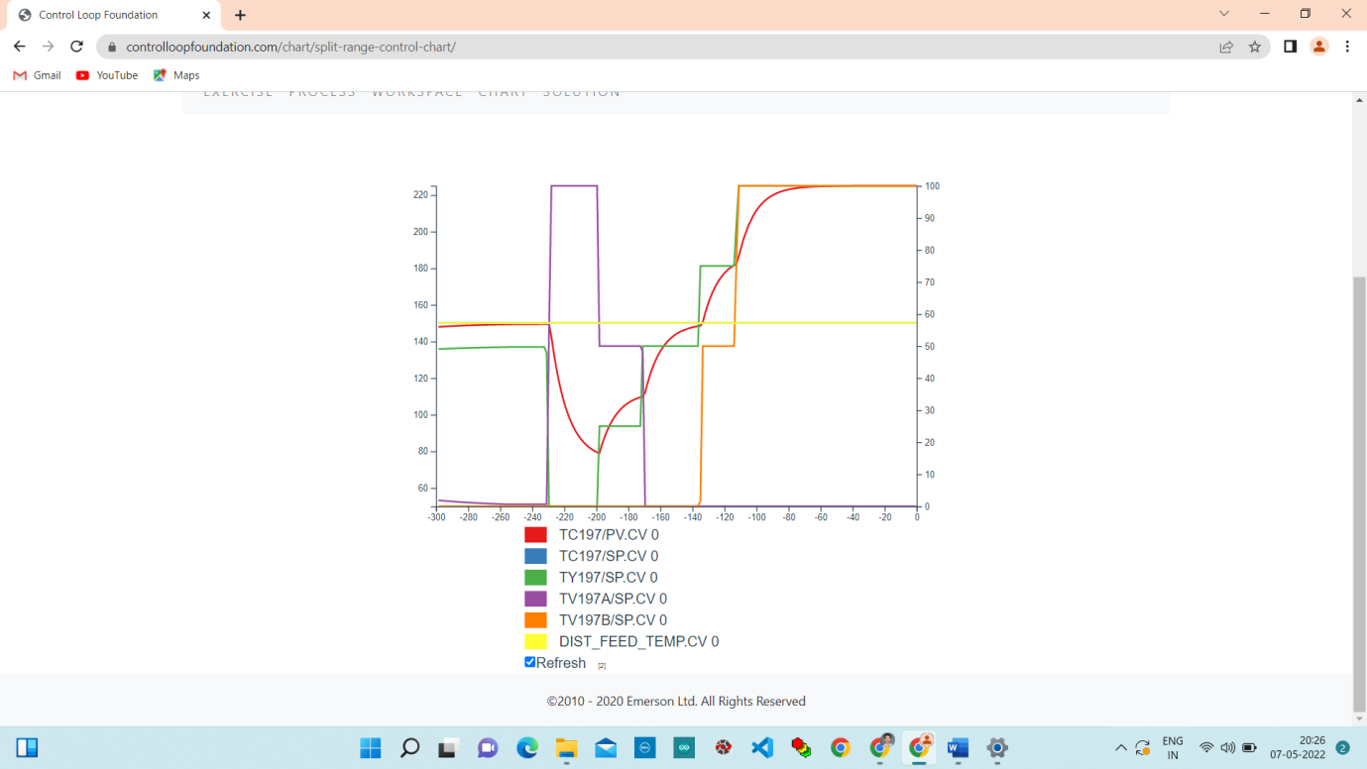

**Step 3.** Change the splitter SP (setpoint) to 50 and wait until the temperature settles to a fixed value.

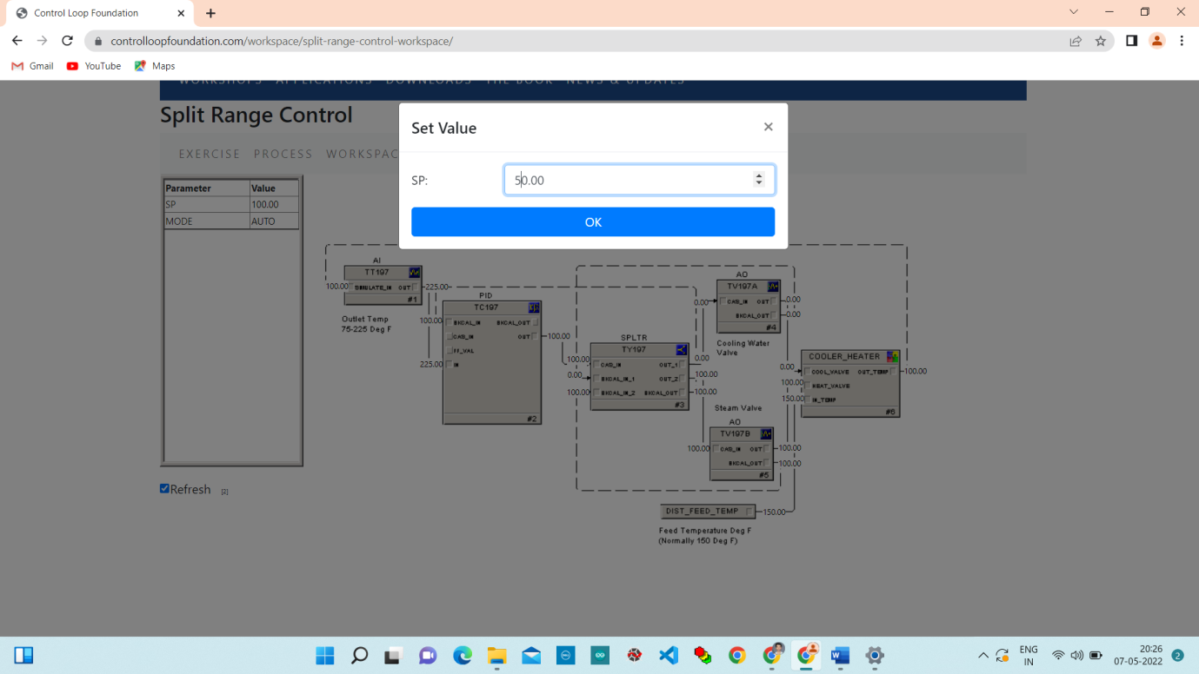

**Chart:**

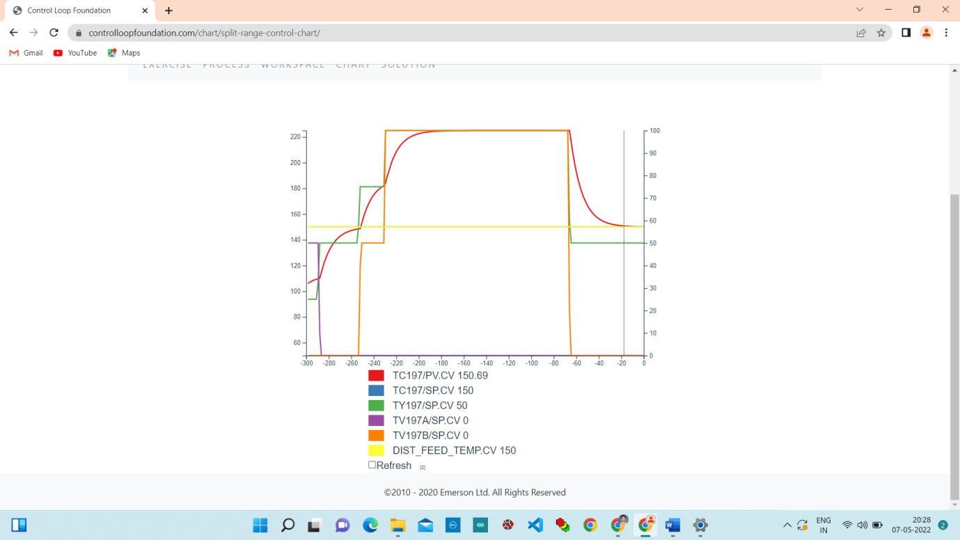

**Step 4.** Make a step change in the FEED_TEMP disturbance and manually adjust the splitter setpoint to get the OUT_TEMP back to its initial value.

Change disturbance value from 150 to 170.

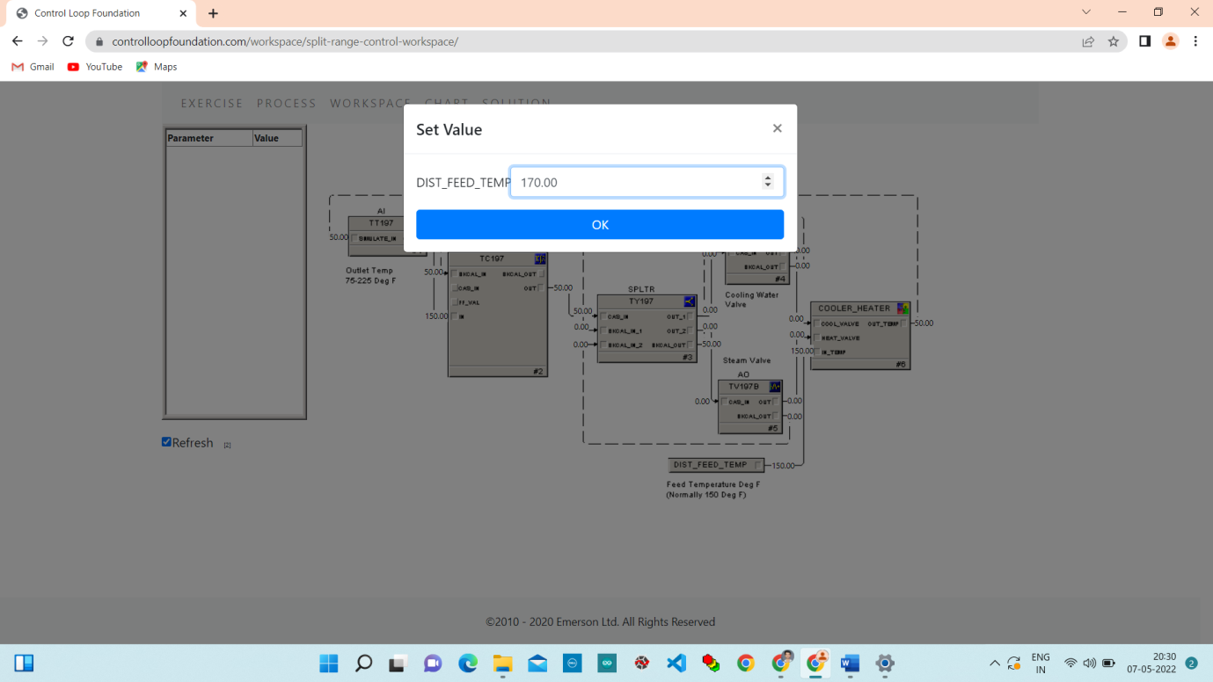

Change Setpoint value from 50 to 40.

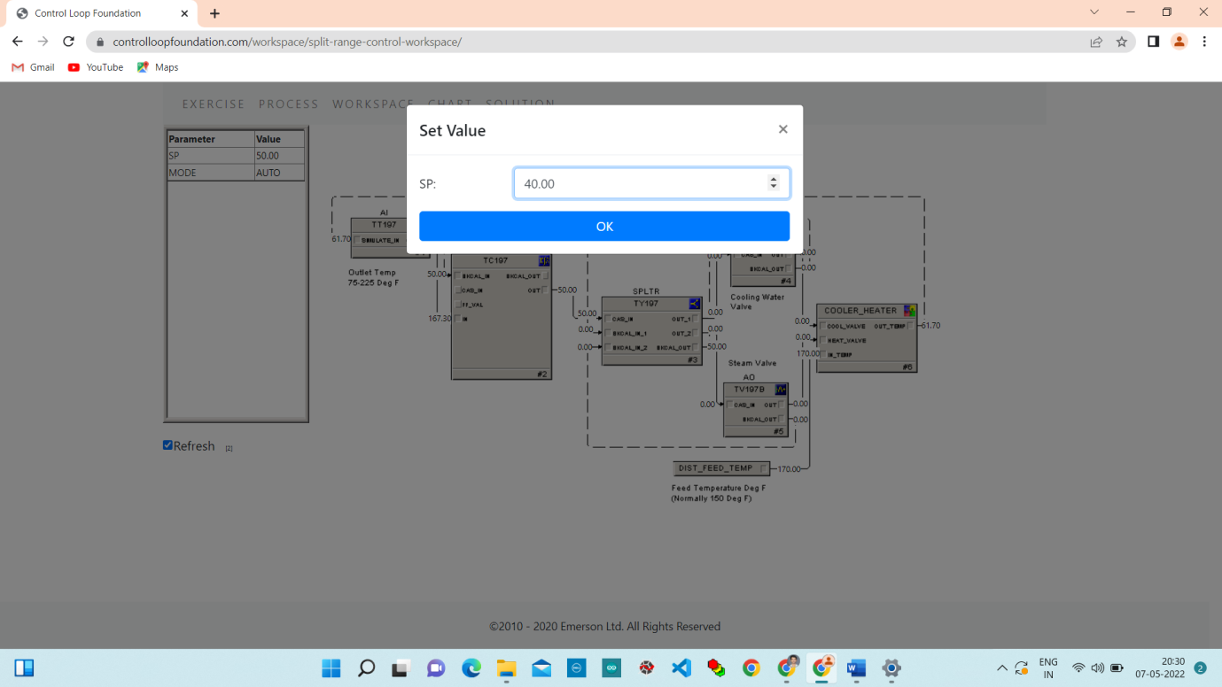

Change Setpoint from 40 to 30.

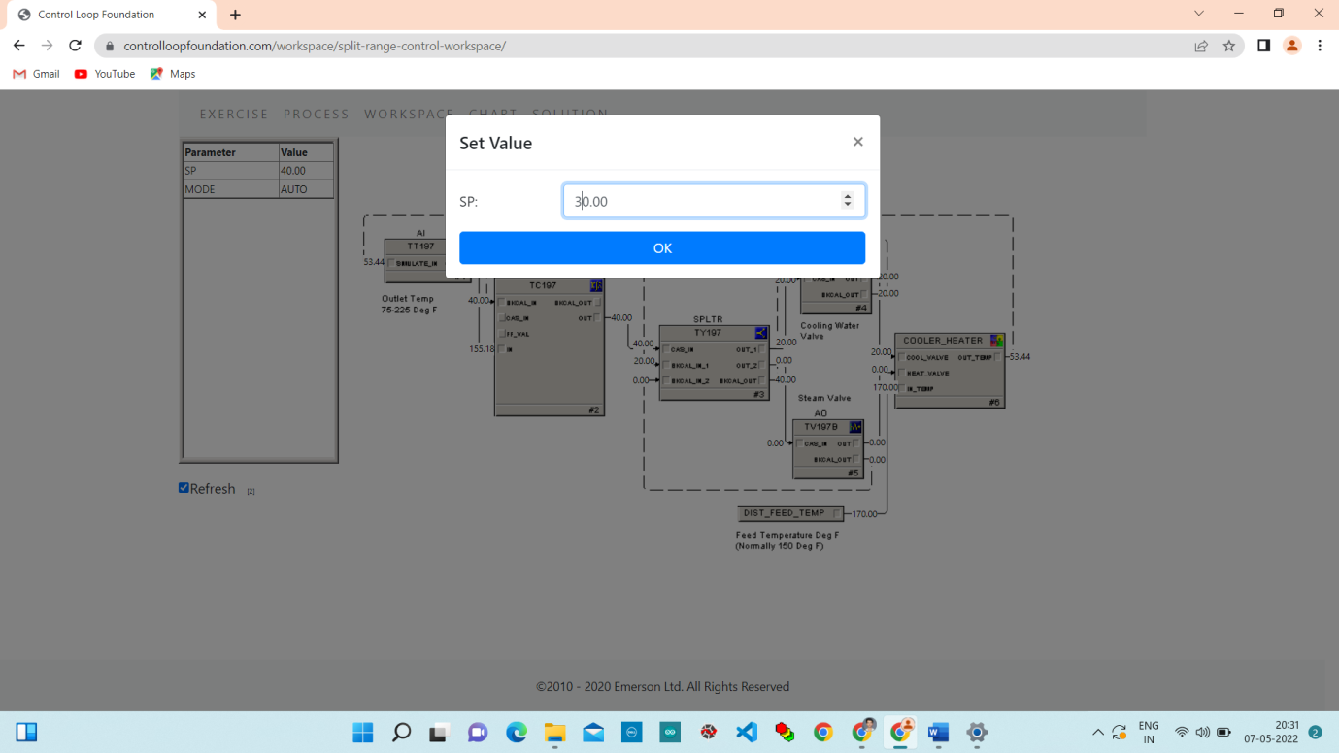

**Chart:**

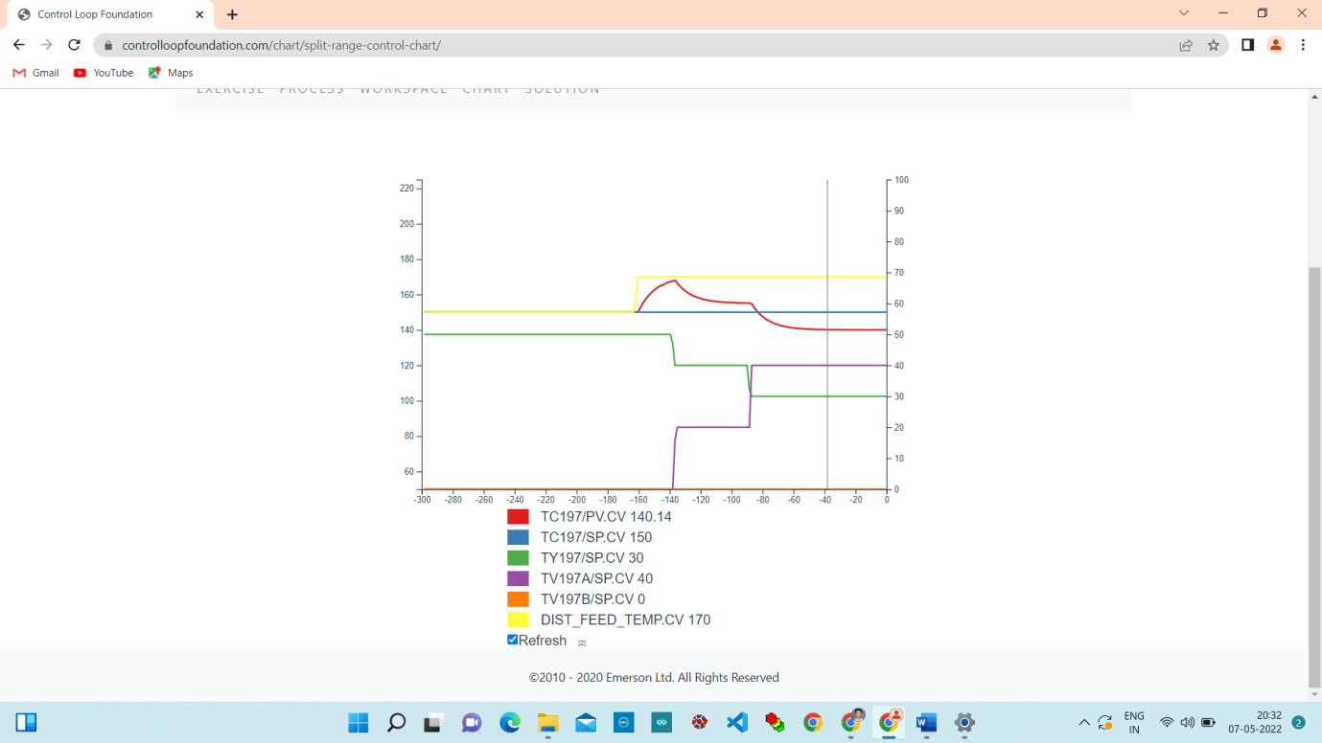

**Step 5.** Change the splitter mode to Cascade, change the temperature control setpoint and observe the response.

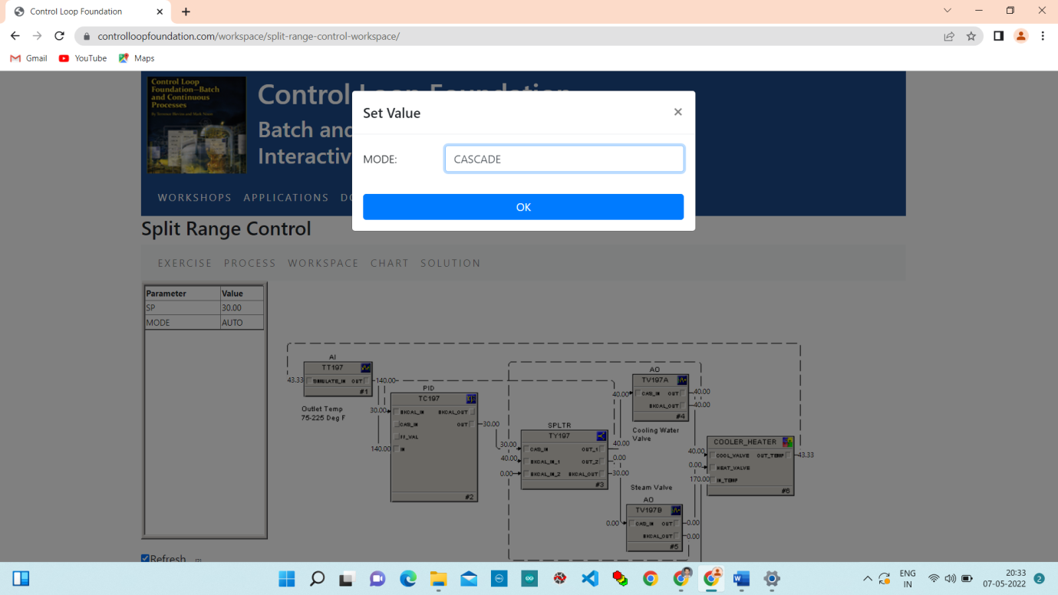

**Chart:**

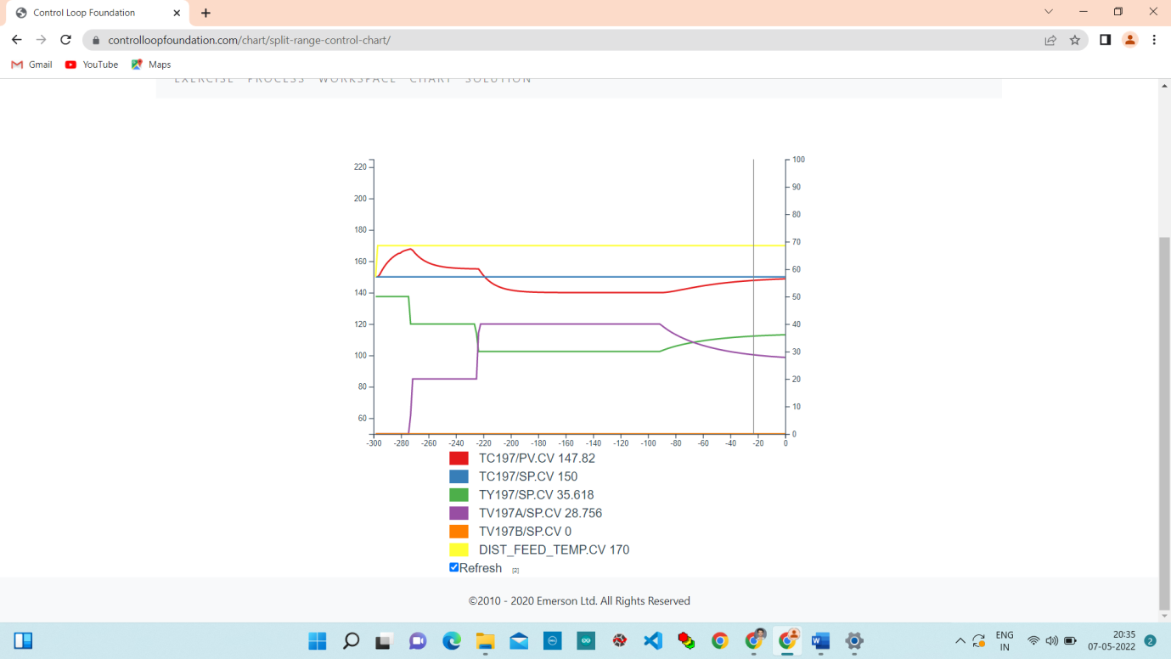

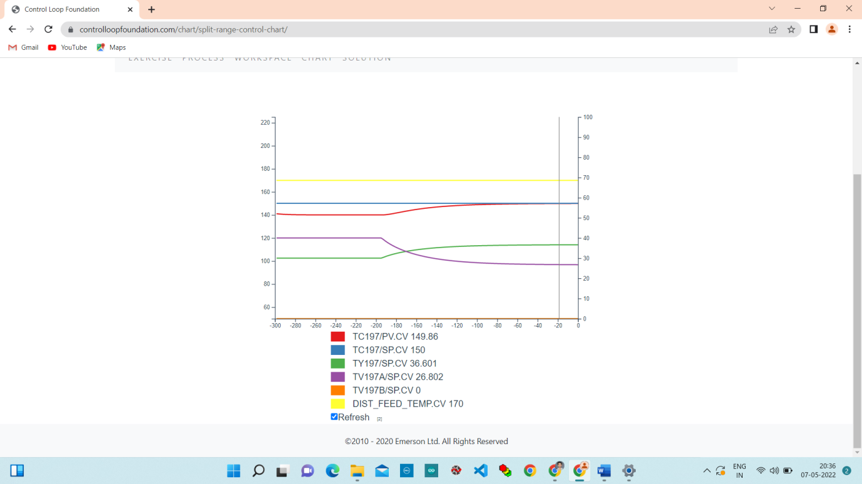

**Conclusion:**

In this lab we studied about split range control using green liquor temperature process example and performed it on controlloop foundation and observe the responses.